Factor Analysis

Notes
Output Created |  | 28-JUN-2021 14:00:48
Comments
Input | Active Dataset | DataSet52
Input | Filter | <none>
Input | Weight | <none>
Input | Split File | <none>
Input | N of Rows in Working Data File | 259
Missing Value Handling | Definition of Missing | MISSING=EXCLUDE: User-defined missing values are treated as missing.
Missing Value Handling | Cases Used | LISTWISE: Statistics are based on cases with no missing values for any variable used.
Syntax |  | FACTOR  /VARIABLES ZGrocery ZTransit ZResidential  /MISSING LISTWISE  /ANALYSIS ZGrocery ZTransit ZResidential  /PRINT UNIVARIATE INITIAL CORRELATION EXTRACTION ROTATION  /FORMAT SORT  /PLOT EIGEN  /CRITERIA FACTORS(3) ITERATE(25)  /EXTRACTION PC  /CRITERIA ITERATE(25)  /ROTATION VARIMAX  /METHOD=COVARIANCE.
Resources | Processor Time | 00:00:00.25
Resources | Elapsed Time | 00:00:00.32
Resources | Maximum Memory Required | 1984 (1.938K) bytes

[DataSet52]

Descriptive Statistics
 | Mean | Std. Deviation | Analysis N
ZGrocery | 2.93789163 | 1.000000593 | 86
ZTransit | 1.13805000 | 1.000000932 | 86
ZResidential | 1.47243151 | .999998978 | 86

Correlation Matrix
 |  | ZGrocery | ZTransit | ZResidential
Correlation | ZGrocery | 1.000 | .771 | -.708
Correlation | ZTransit | .771 | 1.000 | -.948
Correlation | ZResidential | -.708 | -.948 | 1.000

Communalities
 | Raw |  | Rescaled
 | Initial | Extraction | Initial | Extraction
ZGrocery | 1.000 | 1.000 | 1.000 | 1.000
ZTransit | 1.000 | 1.000 | 1.000 | 1.000
ZResidential | 1.000 | 1.000 | 1.000 | 1.000

Extraction Method: Principal Component Analysis.

Total Variance Explained
 | Component | Initial Eigenvaluesª |  |  | Extraction Sums of Squared Loadings
 | Component | Total | % of Variance | Cumulative % | Total | % of Variance
Raw | 1 | 2.622 | 87.402 | 87.402 | 2.622 | 87.402
Raw | 2 | .331 | 11.047 | 98.449 | .331 | 11.047
Raw | 3 | .047 | 1.551 | 100.000 | .047 | 1.551
Rescaled | 1 | 2.622 | 87.402 | 87.402 | 2.622 | 87.402
Rescaled | 2 | .331 | 11.047 | 98.449 | .331 | 11.047
Rescaled | 3 | .047 | 1.551 | 100.000 | .047 | 1.551

Total Variance Explained
 | Component | Extraction Sums of Squared Loadingsª | Rotation Sums of Squared Loadings
 | Component | Cumulative % | Total | % of Variance | Cumulative %
Raw | 1 | 87.402 | 1.744 | 58.141 | 58.141
Raw | 2 | 98.449 | 1.190 | 39.667 | 97.808
Raw | 3 | 100.000 | .066 | 2.192 | 100.000
Rescaled | 1 | 87.402 | 1.744 | 58.141 | 58.141
Rescaled | 2 | 98.449 | 1.190 | 39.667 | 97.808
Rescaled | 3 | 100.000 | .066 | 2.192 | 100.000

Extraction Method: Principal Component Analysis.
a. When analyzing a covariance matrix, the initial eigenvalues are the same across the raw and rescaled solution.

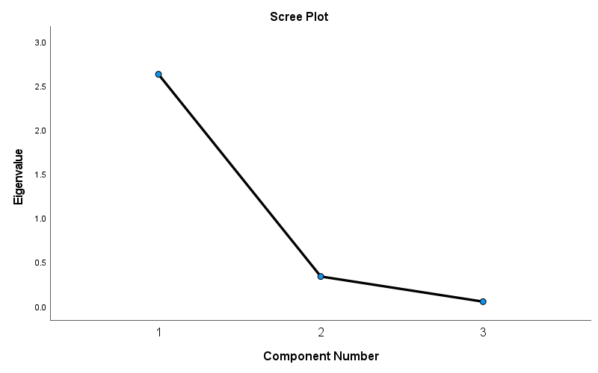

Component Matrixª
 | Raw |  |  | Rescaled
 | Component |  |  | Component
 | 1 | 2 | 3 | 1 | 2 | 3
ZTransit | .973 | -.165 | .161 | .973 | -.165 | .161
ZResidential | -.952 | .273 | .141 | -.952 | .273 | .141
ZGrocery | .877 | .479 | -.025 | .877 | .479 | -.025

Extraction Method: Principal Component Analysis.ª
a. 3 components extracted.

Rotated Component Matrixª
 | Raw |  |  | Rescaled
 | Component |  |  | Component
 | 1 | 2 | 3 | 1 | 2 | 3
ZResidential | -.926 | -.374 | .057 | -.926 | -.374 | .057
ZTransit | .854 | .458 | .245 | .854 | .458 | .245
ZGrocery | .397 | .917 | .048 | .397 | .917 | .048

Extraction Method: Principal Component Analysis.
Rotation Method: Varimax with Kaiser Normalization.ª
a. Rotation converged in 4 iterations.

Component Transformation Matrix
Component | 1 | 2 | 3
1 | .786 | .612 | .086
2 | -.614 | .789 | -.006
3 | -.072 | -.048 | .996

Extraction Method: Principal Component Analysis.
Rotation Method: Varimax with Kaiser Normalization.

